 P

**Index**

|  |  |
| --- | --- |
| **SI.** | **Problem Statement** |
| **1** | Write a program on signal operation - addition, shifting, folding, multiplication. |
| **2** | Visualization of Discreate time signals: Impulse ,steps and Ramps signals |
| **3** | Explain and implementation of Convolution operation of sequences |
| **4** | Explain and implementation of Correlation operation of sequences. |
| **5** | Write a program on PPG signal - filtering, feature extraction, peak detection |
| **6** | Explain and implementation of fourier series decomposition |
| **7** | Write a program on DFT (Discrete Fourier Transform) and IDFT. |
| **8** | Explain and implementation of fourier transform |

**#Problem 1:**

import numpy as np

import matplotlib.pyplot as plt

def signal_addition(x1, x2):

return x1 + x2

def signal_multiplication(x1, x2):

return x1 * x2

def signal_scaling(x, alpha):

return alpha * x

def signal_shifting(n, shift):

return n + shift

def signal_folding(x):

return np.flip(x)

n = np.array([-2, -1, 0, 1, 2])

x1 = np.array([1, 2, 3, 4, 5])

x2 = np.array([5, 4, 3, 2, 1])

added_signal = signal_addition(x1, x2)

multiplied_signal = signal_multiplication(x1, x2)

scaled_signal = signal_scaling(x1, 2)

shifted_signal1 = signal_shifting(n, -2)

shifted_signal2 = signal_shifting(n, 2)

folded_signal = signal_folding(x1)

plt.figure(figsize=(12, 10))

plt.subplot(4, 2, 1)

plt.stem(n, x1)

plt.xlabel("Time")

plt.ylabel("Amplitude")

plt.title("Original Signal x1")

plt.grid()

plt.subplot(4, 2, 2)

plt.stem(n, x2)

plt.xlabel("Time ")

plt.ylabel("Amplitude")

plt.title("Original Signal x2")

plt.grid()

plt.subplot(4, 2, 3)

plt.stem(n, added_signal)

plt.xlabel("Time")

plt.ylabel("Amplitude")

plt.title("Signal Addition")

plt.grid()

plt.subplot(4, 2, 4)

plt.stem(n, multiplied_signal)

plt.xlabel("Time")

plt.ylabel("Amplitude")

plt.title("Signal Multiplication")

plt.grid()

plt.subplot(4, 2, 5)

plt.stem(n, scaled_signal)

plt.xlabel("Time")

plt.ylabel("Amplitude")

plt.title("Scaled Signal (x1 * 2)")

plt.grid()

plt.subplot(4, 2, 6)

plt.stem(shifted_signal1, x1)

plt.xlabel("Time")

plt.ylabel("Amplitude")

plt.title("Shifted Signal (Shift = -2)")

plt.grid()

plt.subplot(4, 2, 7)

plt.stem(shifted_signal2, x1)

plt.xlabel("Time")

plt.ylabel("Amplitude")

plt.title("Shifted Signal (Shift = +2)")

plt.grid()

plt.subplot(4, 2, 8)

plt.stem(n, folded_signal)

plt.xlabel("Time")

plt.ylabel("Amplitude")

plt.title("Folded Signal (x1)")

plt.grid()

plt.tight_layout()

plt.show()

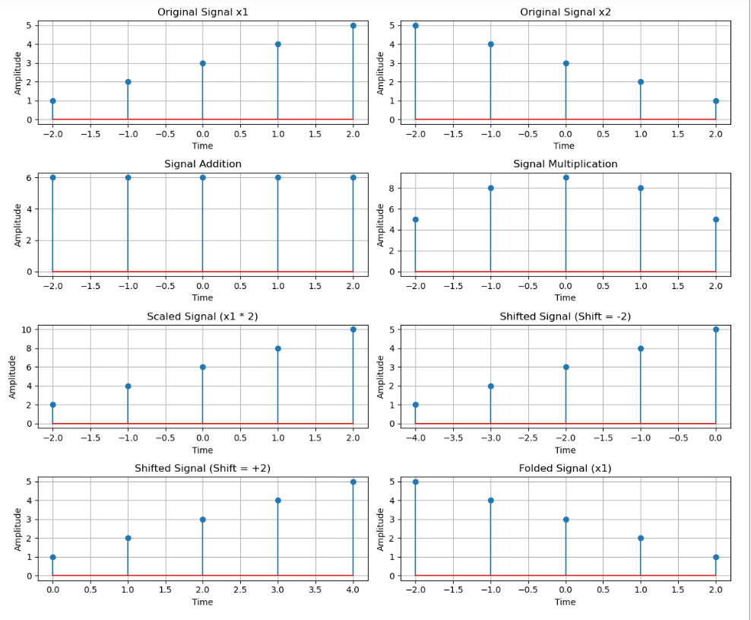

**#Problem 2:**

import numpy as np

import matplotlib.pyplot as plt

n = np.arange(-20, 20)  # Discrete time index

impulse = np.where(n == 0, 1, 0)

step = np.where(n >= 0, 1, 0)

ramp = np.where(n >= 0, n, 0)

plt.figure(figsize=(12, 6))

plt.subplot(1, 3, 1)

plt.stem(n, impulse, use_line_collection=True)

plt.title("Impulse Signal")

plt.xlabel("n")

plt.ylabel("Amplitude")

plt.grid()

plt.subplot(1, 3, 2)

plt.stem(n, step, use_line_collection=True)

plt.title("Step Signal")

plt.xlabel("n")

plt.ylabel("Amplitude")

plt.grid()

plt.subplot(1, 3, 3)

plt.stem(n, ramp, use_line_collection=True)

plt.title("Ramp Signal")

plt.xlabel("n")

plt.ylabel("Amplitude")

plt.grid()

plt.tight_layout()

plt.show()

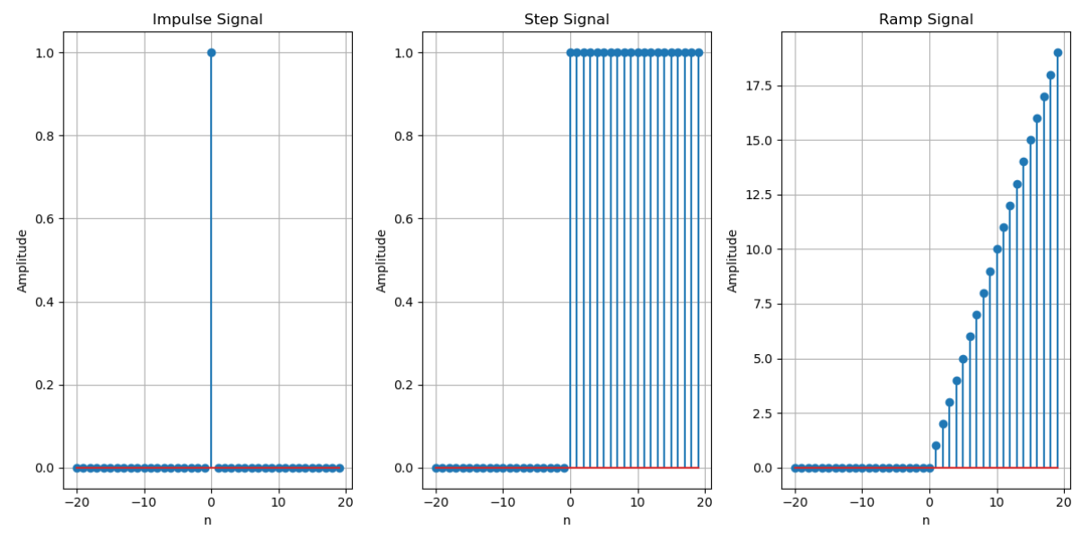

**#Problem 3:**

import numpy as np

import matplotlib.pyplot as plt

from scipy.signal import convolve

def compute_convolution(signal1, signal2):

conv_result = convolve(signal1, signal2, mode='full', method='auto')

return conv_result

fs = 1000

t = np.linspace(0,1,fs, endpoint=False)

freq = 5

sin_signal=np.sin(2 * np.pi * freq * t)

conv_auto = compute_convolution(sin_signal, sin_signal)

signal1 = sin_signal

signal2 = np.roll(signal1, 100)

conv_shifted = compute_convolution(signal1, signal2)

noise = np.random.normal(0, 0.5, fs)

noisy_signal = signal1+ noise

conv_noisy = compute_convolution(signal1, noisy_signal)

plt.figure(figsize=(12,6))

plt.subplot(3, 1, 1)

plt.plot(conv_auto)

plt.title("Autoconvolution of a Sinusoidal Signal")

plt.xlabel("Samples")

plt.ylabel("Convolution Output")

plt.grid()

plt.subplot(3, 1, 2)

plt.plot(conv_shifted)

plt.title("Convolution between Signal and Shifted Version")

plt.xlabel("Samples")

plt.ylabel("Convolution Output")

plt.grid()

plt.subplot(3, 1, 3)

plt.plot(conv_noisy)

plt.title("Convolution with Noisy Signal")

plt.xlabel("Samples")

plt.ylabel("Convolution Output")

plt.grid()

plt.tight_layout()

plt.show()

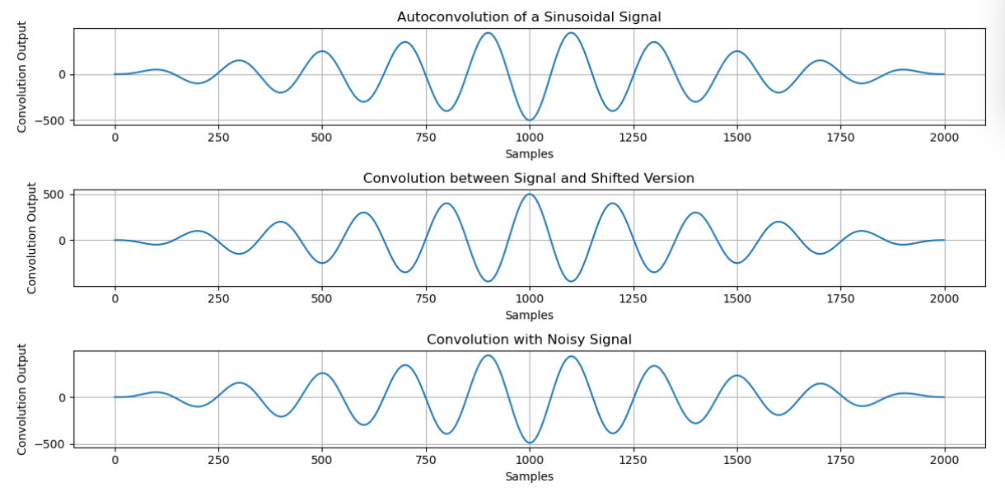

**#Problem 4:**

import numpy as np

import matplotlib.pyplot as plt

from scipy.signal import correlate, correlation_lags

def compute_autocorrelation(signal):

    auto_corr = correlate(signal, signal, mode='full', method='auto')

    lags = correlation_lags(len(signal), len(signal), mode='full')

    return auto_corr, lags

def compute_cross_correlation(signal1, signal2):

    cross_corr = correlate(signal1, signal2, mode='full', method='auto')

    lags = correlation_lags(len(signal1), len(signal2), mode='full')

    return cross_corr, lags

fs = 1000

t = np.linspace(0, 1, fs, endpoint=False)

freq = 5

sin_signal = np.sin(2 * np.pi * freq * t)

auto_corr, lags_auto = compute_autocorrelation(sin_signal)

signal1 = sin_signal

signal2 = np.roll(signal1, 100)

cross_corr, lags_cross = compute_cross_correlation(signal1, signal2)

noise = np.random.normal(0, 0.5, fs)

noisy_signal = signal1 + noise

cross_corr_noise, lags_noise = compute_cross_correlation(signal1, noisy_signal)

plt.figure(figsize=(12, 12))

plt.subplot(3, 1, 1)

plt.plot(lags_auto, auto_corr)

plt.title("Autocorrelation of a Sinusoidal Signal")

plt.xlabel("Lag")

plt.ylabel("Autocorrelation")

plt.grid()

plt.subplot(3, 1, 2)

plt.plot(lags_cross, cross_corr)

plt.title("Cross-Correlation between Two Signals")

plt.xlabel("Lag")

plt.ylabel("Cross-Correlation")

plt.grid()

plt.subplot(3, 1, 3)

plt.plot(lags_noise, cross_corr_noise)

plt.title("Cross-Correlation with Noisy Signal")

plt.xlabel("Lag")

plt.ylabel("Cross-Correlation")

plt.grid()

plt.tight_layout()

plt.show()

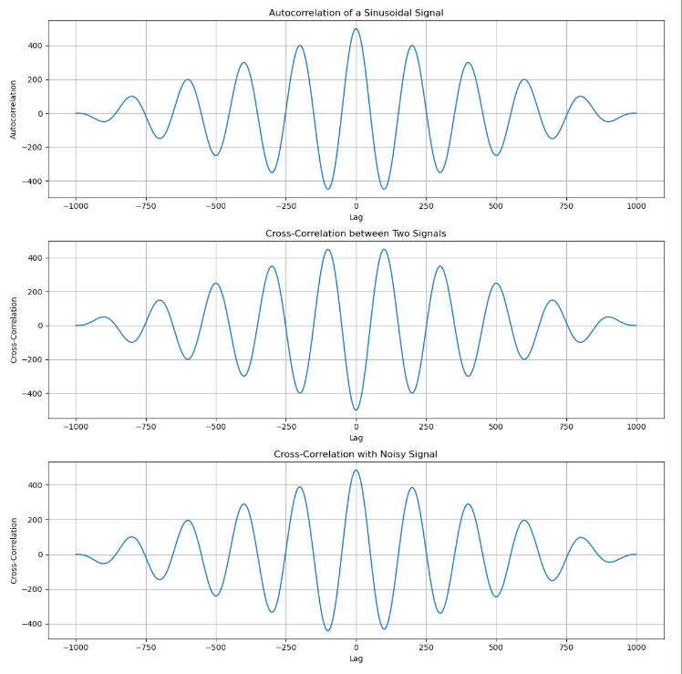

**#Problem 5:**

import numpy as np

import matplotlib.pyplot as plt

from scipy.signal import find_peaks

fs = 100

t = np.linspace(0, 10, 10 * fs)

# Create a synthetic PPG-like waveform using a sum of sinusoids and added noise

ppg = 0.6 * np.sin(2 * np.pi * 1.2 * t) + 0.4 * np.sin(2 * np.pi * 2.4 * t) + 0.05 * np.random.randn(len(t))

ppg = ppg - np.min(ppg)  # baseline shift

# Detect systolic peaks using a prominence filter

min_prominence = 0.2  # adjust this value based on your signal

peaks, peak_props = find_peaks(ppg, prominence=min_prominence, distance=fs/2)

systolic_peaks = peaks  # indices of systolic peaks

diastolic_points = []

for i in range(len(systolic_peaks)-1):

    start = systolic_peaks[i]

    end = systolic_peaks[i+1]

    segment = ppg[start:end]

    if len(segment) > 0:

        local_min = np.argmin(segment) + start

        diastolic_points.append(local_min)

diastolic_points = np.array(diastolic_points)

if len(systolic_peaks) > 1:

    ibi = np.diff(systolic_peaks) / fs

    heart_rate = 60 / np.mean(ibi)

else:

    heart_rate = np.nan

print("Detected systolic peaks (sample indices):", systolic_peaks)

print("Detected diastolic points (sample indices):", diastolic_points)

print("Estimated Heart Rate (BPM):", heart_rate)

# Plot the results

plt.figure(figsize=(12, 4))

plt.plot(t, ppg, label="PPG Signal")

plt.plot(t[systolic_peaks], ppg[systolic_peaks], "ro", label="Systolic Peaks")

plt.plot(t[diastolic_points], ppg[diastolic_points], "go", label="Diastolic Points")

plt.xlabel("Time (s)")

plt.ylabel("Amplitude")

plt.legend()

plt.title("PPG Signal Feature Extraction")

plt.show()

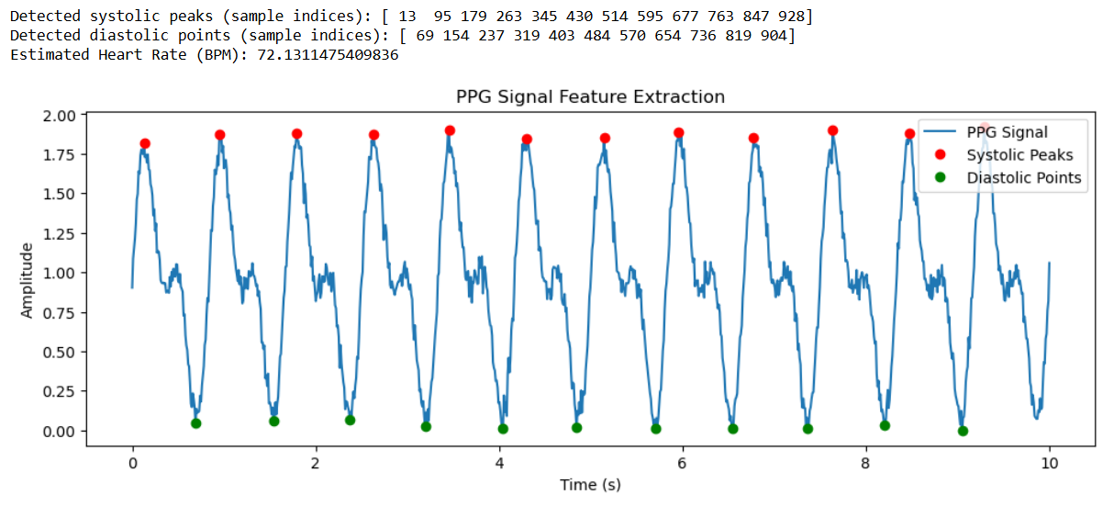

**#Problem 6:**

import numpy as np

import matplotlib.pyplot as plt

from scipy.integrate import quad

# Define the periodic function (square wave in this case)

def f(x):

    return 1 if x < np.pi else -1

# Fourier coefficients

T = 2 * np.pi  # Period

omega = 2 * np.pi / T

# Compute a0

a0 = (1 / T) * quad(lambda x: f(x), 0, T)[0]

def an(n):

    return (2 / T) * quad(lambda x: f(x) * np.cos(n * omega * x), 0, T)[0]

def bn(n):

    return (2 / T) * quad(lambda x: f(x) * np.sin(n * omega * x), 0, T)[0]

# Reconstruct function using Fourier series

def fourier_series(x, terms=10):

    sum_terms = a0 / 2  # DC component

    for n in range(1, terms + 1):

        sum_terms += an(n) * np.cos(n * omega * x) + bn(n) * np.sin(n * omega * x)

# Plot original function and Fourier approximation

x_vals = np.linspace(0, 2 * np.pi, 400)

f_vals = np.array([f(x) for x in x_vals])

fourier_vals = np.array([fourier_series(x, terms=10) for x in x_vals])

plt.figure(figsize=(8, 4))

plt.plot(x_vals, f_vals, label='Original Function', linestyle='dashed')

plt.plot(x_vals, fourier_vals, label='Fourier Approximation (10 terms)')

plt.legend()

plt.xlabel('x')

plt.ylabel('f(x)')

plt.title('Fourier Series Approximation of a Square Wave')

plt.grid()

plt.show()

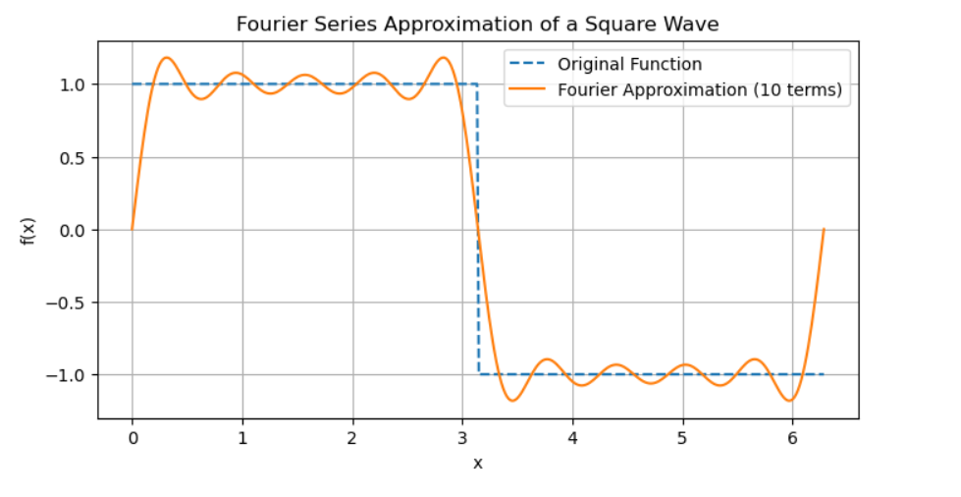

**#Problem 7:**

import numpy as np

import matplotlib.pyplot as plt

def DFT(x):

    """

    Compute the Discrete Fourier Transform (DFT) of a 1D signal.

    """

    N = len(x)

    X = np.zeros(N, dtype=complex)  # Output array (complex numbers)

    for k in range(N):  # Loop over frequency bins

        for n in range(N):  # Loop over time samples

            X[k] += x[n] * np.exp(-2j * np.pi * k * n / N)

    return X

# Create a sample signal (two sine waves)

Fs = 1000  # Sampling rate

T = 1 / Fs  # Sampling interval

t = np.linspace(0, 1, Fs, endpoint=False)  # 1 second duration

# Signal: Combination of 50 Hz and 120 Hz sine waves

f1, f2 = 50, 120

signal = np.sin(2 * np.pi * f1 * t) + 0.5 * np.sin(2 * np.pi * f2 * t)

# Compute DFT

dft_output = DFT(signal)

# Compute frequency bins

freqs = np.fft.fftfreq(len(dft_output), T)

# Plot magnitude spectrum (single-sided)

plt.figure(figsize=(10, 5))

plt.plot(freqs[:Fs//2], np.abs(dft_output[:Fs//2]))  # Single-sided spectrum

plt.title("DFT Frequency Spectrum")

plt.xlabel("Frequency (Hz)")

plt.ylabel("Magnitude")

plt.grid()

plt.show()

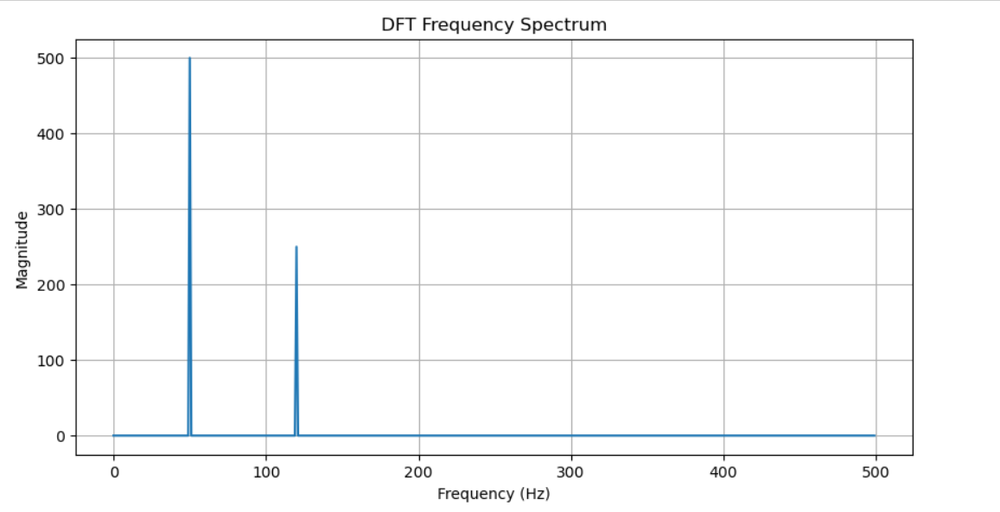

**#Problem 8:**

import numpy as np

import matplotlib.pyplot as plt

from scipy.fft import fft, ifft, fftfreq

# Generate a sample audio signal

Fs = 1000  # Sampling rate (1000 Hz)

T = 1 / Fs  # Sampling interval

t = np.linspace(0, 1, Fs, endpoint=False)  # 1 second time vector

# Generate a pure sine wave (440 Hz, like an "A4" musical note)

freq_signal = 440

pure_signal = np.sin(2 * np.pi * freq_signal * t)

# Add random noise

noise = np.random.normal(0, 0.5, pure_signal.shape)

noisy_signal = pure_signal + noise

# Apply FFT

fft_signal = fft(noisy_signal)

freqs = fftfreq(len(fft_signal), T)  # Frequency bins

# Filter: Remove frequencies higher than 500 Hz

fft_filtered = fft_signal.copy()

fft_filtered[np.abs(freqs) > 500] = 0  # Zero out high frequencies (noise)

# Apply Inverse FFT to get the cleaned signal

cleaned_signal = ifft(fft_filtered).real

# Plot the results

plt.figure(figsize=(12, 6))

plt.subplot(3, 1, 1)

plt.plot(t, pure_signal, label="Original Signal (440 Hz)")

plt.legend()

plt.title("Original Pure Signal")

plt.subplot(3, 1, 2)

plt.plot(t, noisy_signal, label="Noisy Signal", color="red")

plt.legend()

plt.title("Noisy Signal")

plt.subplot(3, 1, 3)

plt.plot(t, cleaned_signal, label="Cleaned Signal (After FFT Filtering)", color="green")

plt.legend()

plt.title("Filtered Signal (Noise Removed)")

plt.tight_layout()

plt.show()

